Lab#9 – Object Oriented Programming Part1
Name | Ben Stobie
Date | 16/04/21

Exercise 1: Classes and Objects
Copy your Python code from the first exercise here. Make sure that your code contains your name and date.
#Ben Stobie
#16/04/21

class Student:
def __init__(self, fname, lname):
self.first_name = fname
self.last_name = lname

def main():
studentName = Student(input("Please enter your first name: "), input("Please enter your last name: "))
print(studentName.first_name, end = " ")
print(studentName.last_name)

main()
#Ben Stobie
#16/04/21

class Student:
def __init__(self, fname, lname):
self.first_name = fname
self.last_name = lname

def main():
studentName1 = Student(input("Please enter your first name: "), input("Please enter your last name: "))
studentName2 = Student(input("Please enter your partner's first name: "), input("Please enter your partner's last name: "))
studentName3 = Student(input("Please enter your partner's first name: "), input("Please enter your partner's last name: "))
print(studentName1.first_name, end = " ")
print(studentName1.last_name)
print(studentName2.first_name, end = " ")
print(studentName2.last_name)
print(studentName3.first_name, end = " ")
print(studentName3.last_name)
main()

Paste screen capture here showing some results
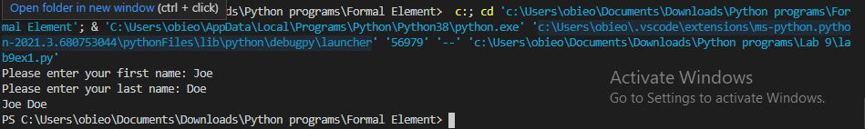
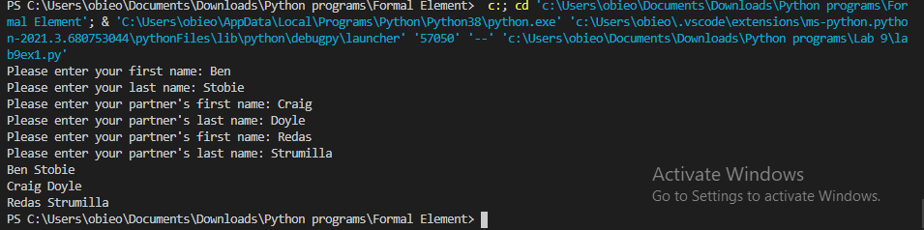

What is the difference between a class and an object? Give an example of each from your code.

The class is the container in which the objects exist, while the objects are the things withing the class that actually are a part of the execution.

How many instance variables are in the student class.
Code 1: 2
Code 2: 6

In exercise1 the instance variables are all “public”. What does being “public” mean?
That they can be called from outside the class, for example : studentName2.last_name

Exercise 2 - constructors
Copy your Python code here for exercise 2. Make sure that your code contains your name and date.
#Ben Stobie
#16/04/21

class Student:
def __init__(self, fname, lname, age):
self.first_name = fname
self.last_name = lname
self.student_age = age

def main():
studentName = Student(input("Please enter your first name: "), input("Please enter your last name: "), input("Please enter your age: "))
print(studentName.first_name, end = " ")
print(studentName.last_name)
print(studentName.student_age)
main()

Paste screen capture here showing some results
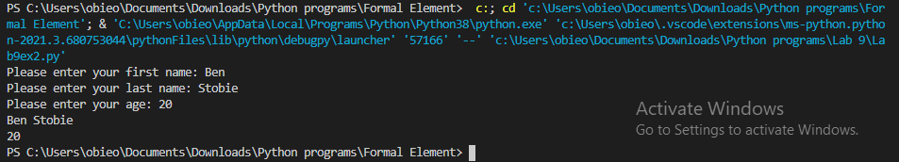

What is the purpose of the initializer in Python?

Exercise 3/4 – data hiding
Copy your Python code here for exercise 3 and 4. Make sure that your code contains your name and date.

Paste screen capture here showing some results

Explain what happened when your main code tried to access a private instance variables?

What is an “Accessor” method? Give examples from your code from exercise 3 and 4.

Exercise 5 – “set” methods
Copy your Python code here for exercise 5. Make sure that your code contains your name and date.

Paste screen capture here showing some results

Explain the purpose of a “mutator” method and give an example of one from your code?

